**Synthesis and Antimicrobial Activity of 5-benzylidenebarbituric acids: A structure -reactivity Study.**

**K. Radhakrishnan1*, P. Mohandass1, S. Sankaralingam2, S. Chandra Mohan3**

1Department of Chemistry, Saraswathi Narayanan College, Perungudi, Madurai – 625022,

Tamil Nadu, India.

2Department of Botany, Saraswathi Narayanan College, Perungudi, Madurai – 625022,

Tamil Nadu, India

3Division of Phyto chemistry, Shanmuga Centre for Medicinal Plants Research, Thanjavur- 613007, Tamil Nadu, India.

*Corresponding author: Email: prskradha61@gmail.com; Contact: +919443686474

**Abstract**

Substituted 5-benzylidene barbituric acids have been prepared and characterized by 1H and 13C NMR spectral analysis. The antimicrobial activities and structure reactivity correlation of the compounds have been studied.

**Keywords:** Substituted 5-benzylidene barbituric acids; antimicrobial, correlation studies.

**INTRODUCTION**

Some barbituric acid derivatives have been widely used as sedative, hypnotic, anticonvulsant, antispasmodic, as well as local anesthetic agents1 -5. Benzylidene barbituric acids are useful as potential organic oxidizers6, for the preparation of oxadeazaflavines7 and for the unsymmetrical synthesis of disulfides8. Some of them have recently studied as nonlinear optical materials9. Several 5-benzylidene barbituric acids were prepared in the absence of solvent by the influence of infrared irradiation. These molecules were obtained by means of a Knoevenagel condensation between barbituric acid and various benzaldehydes10.

Studies of substituted effects on zone of inhibition against the growth of microorganisms in various substituted N-(1-piperidino benzyl) nicotinamide11 and substituted N-(1-piperidinobenzyl) acetamide12 and substituted N-(1-morpholinobenzoyl) acetamide12 have been reported. Recently we have reported the substituent effects on zone of inhibition against the growth of microorganisms in various substituted 2-benzylidene-1,3-indandiones13. In continuation of our research interest in the structure - reactivity study, we have synthesized substituted 5-benzylidene barbituric acids and studied the antimicrobial activity to find out the substituent effect on 5-benzylidene barbituric acid.

**MATERIALS AND METHODS**

All chemical used were purchased from Sigma Aldrich. Purity of the compounds was checked by TLC on silica gel G plate. 1H and 13C spectra were obtained on a BRUKER AMX 400 MHz spectrometer. Chemical shift of 1H were measured with the peak of DMSO at δ 3.42 as the internal reference, while those of 13C were recorded with the central peak of DMSO at δ 39.90 as the internal reference.

**General procedure for the synthesis of 5-benzylidenebarbituric acids (1 to 7)**

Preparation of 5-benzylidene barbituric acid and its substituted compounds (1 to 7) were done as per the reported procedure14.

To the calculated amount of the pure benzaldehyde (2 g, 0.015 mol) and barbituric acid (1.55g, 0.015 mol) in warm ethyl alcohol was added a 10% solution of sodium hydroxide (catalytic amount) and the reaction mixture stirred for 2 hours. After completion of the reaction as indicated by TLC, the reaction mixture was left overnight (scheme I). Solid product was separated by filtration and washed several times with cold methanol.



Scheme I: Synthesis of 5-benzylidene barbituric acids.

Spectral analysis of compounds (1 to 7)

Compound 1: 5-(4’-methoxybenzylidene) barbituric acid

1H NMR: δ 3.877 (s,3H), 7.065 (d,2H), 8.252 (s,1H), 8.369 (d,2H), 11.175 (s,1H), 11.302 (s,1H); 13C NMR: δ 56.22,114.41,116.00,125.62,137.96,150.67,155.46,162.64,163.92,164.39.

Compound 2: 5-(4’-hydroxybenzylidene) barbituric acid

1H NMR: δ 6.878 (d,2H), 8.213 (s,1H), 8.320 (d,2H), 10.851 (s,1H), 11.117(s,1H), 11.249 (s,1H);

13C NMR: δ 114.61, 115.97, 124.24, 138.77, 150.70, 156.05,162.75,163.48,164.59.

Compound 3: 5-(4’-methylbenzylidene) barbituric acid

1H NMR: δ 2.385 (s,3H), 7.304 (d,2H), 8.094 (d,2H), 8.255 (s,1H), 11.218 (s,1H), 11.365 (s,1H);

13C NMR: δ 118.30, 129.33, 130.31, 134043, 143.96, 150.68, 155.46, 162.26, 164.08.

Compound 4: 5-benzylidene barbituric acid

1H NMR: δ 7.485 (m,3H), 8.073 (d,2H), 8.285 (s,1H), 11.238 (s,1H), 11.397 (s,1H); 13C NMR: δ 119.55, 128.52, 132.69, 133.11, 133.54, 150.69, 155.20, 162.03, 163.87.

Compound 5: 5-(4’-chlorobenzylidene) barbituric acid

1H NMR: δ 7.518 (d,2H), 8.069 (d,2H), 8.243 (s,1H), 11.275 (s,1H), 11.425 (s,1H); 13C NMR:

δ 120.09, 128.55, 132.01, 135.15, 137.21, 150.65, 153.52, 162.04, 163.67.

Compound 6: 5-(4’-bromobenzylidene) barbituric acid

1H NMR: δ 7.670 (d,2H), 7.979 (d,2H), 8.223 (s,1H), 11.272 (s,1H), 11.421 (s,1H); 13C NMR: δ 120.09, 128.55, 132.01, 135.15, 137.21, 150.65, 153.52, 162.04, 163.67.

Compound 7: 5-(4’-nitrobenzylidene) barbituric acid

1H NMR: δ 8.017 (d,2H), 8.245 (d,2H), 8.324 (s,1H), 11.329 (s,1H), 1.504 (s,1H); 13C NMR: δ

120.24, 126.29, 131.51, 132.40, 135.15, 150.65, 153.56, 162.04, 163.67.

Antimicrobial Activity:

Agar well-diffusion method was followed to determine the  
antimicrobial activity [10]. Nutrient agar (NA) and Potato Dextrose Agar (PDA) plates were  
swabbed (sterile cotton swabs) with 8 hours old -broth culture of respective bacteria. Wells (6 mm) were made in each of these plates using sterile cork borer. Briefly, agar plates were  
inoculated with bacterial strain under aseptic conditions and wells (diameter = 6 mm) were  
filled with 50 µl of the test samples and incubated at 37°C for 24 hours. After the incubation  
period, the diameter of the growth of inhibition zones were measured.   
 Three inhibition zone diameter measurements were taken for each well and averaged, for each replicates the readings were taken in three different fixed directions and the average values were recorded. The average inhibition zone diameter for the various bacteria are shown in Table 1.

**RESULTS AND DISCUSSION**

In this study, gram-positive bacteria (Staphylococcus aureus) and five gram-negative bacteria

(Escherichia coli, Klebsiella oxytoca, Proteus mirabilis,Pseudomonas aeruginosa and Shigella sonnei)were used. The result of the present study showed a broad range of antibacterial activity.

The order of antibacterial activity of compounds (1 to 7) for all the microorganism were in the following sequence.

-OCH3< -OH < -CH3 < -H < -Cl < -Br< -NO2

Table 1. Antibacterial activity (zone of inhibition(mm) values) of substituted 5-benzylidenebarbituric acid

|  |  |  |  |  |  |  |  |  |  |
| --- | --- | --- | --- | --- | --- | --- | --- | --- | --- |
| **S.No.** | **Name of the microorganism** | **Inhibition zone diameter** | | | | | | |  |
| **Standard (Amphotericin-B)** | **-OCH3** | **-OH** | **-CH3** | **-H** | **-Cl** | **-Br** | **-NO2** |
| 1 | Escherichia coli | 21 | 9 | 10 | 12 | 14 | 16 | 17 | 20 |
| 2 | Klebsiella oxytoca | 16 | 8 | 12 | 14 | 16 | 20 | 24 | 28 |
| 3 | Proteus mirabilis | 18 | 7 | 9 | 10 | 11 | 16 | 19 | 22 |
| 4 | Pseudomonas aeruginosa | 21 | 11 | 13 | 15 | 16 | 20 | 23 | 28 |
| 5 | Shigella Sonnei | 16 | 8 | 10 | 11 | 12 | 14 | 18 | 21 |
| 6 | Staphylococcus aureus | 18 | 7 | 12 | 13 | 14 | 16 | 23 | 28 |

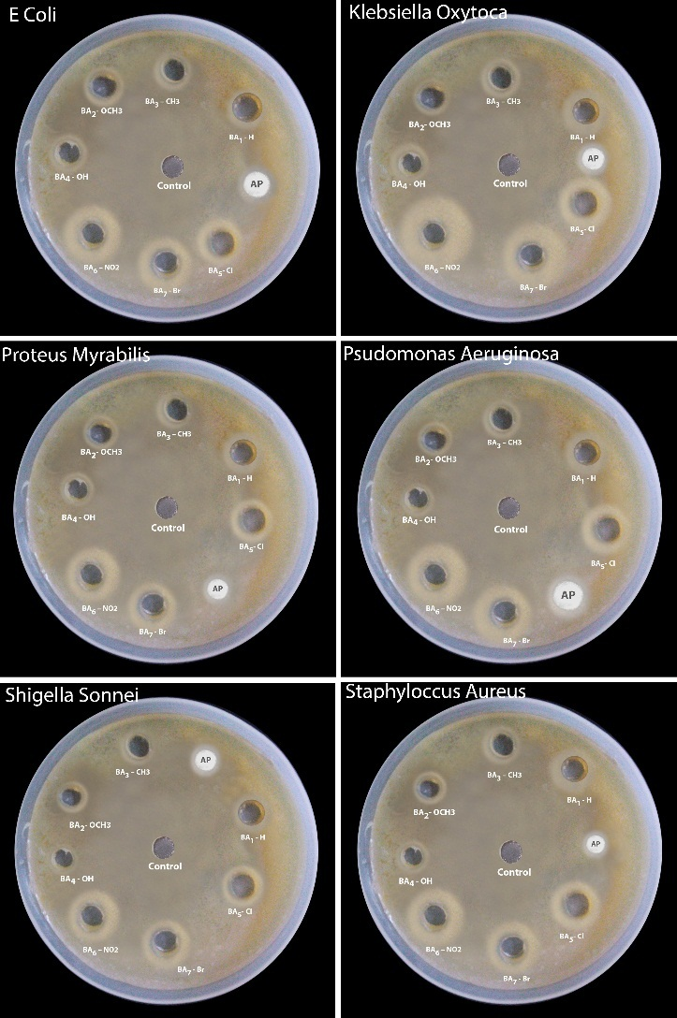

Figure 1: Antibacterial activity of substituted 5-benzylidenebarbituric acid

In order to express the effect of substituents quantitatively it was considered worthwhile to correlate the logarithm of inhibition zone diameter (IZD) of (1 to 7) at the same concentration with the Hammett substituent constants for all the microorganisms. The results of statistical SSP analysis are given in **Table 2.** The corresponding Hammett plot for Klebsiella oxytoca is shown in **Figure2**.

The positive value of the reaction constant (ρ) equation 1 indicates that electron withdrawing substituents increase the antibacterial activity and electron releasing substituents retard it.

Log (IZD) = (0.37± 0.04) σp+ / σp + (1.21± 0.02) (1)

(r = 0.978, n=7, F = 108.99)

**Table 2**: Results of statistical treatment of log IZD (mm) with σp, σpo, σp+, σp+/ σp,σp+/ σp-, σp+/ σp/ σp-substituent constants using single parameter equation

|  |  |  |  |  |  |  |  |  |
| --- | --- | --- | --- | --- | --- | --- | --- | --- |
| S.No. | Bacteria | Scale | ρ | r | s | F | Log(IZD)o | n |
| 1 | *Escherichia coli* | σP | 0.31±0.05 | 0.937 | 0.048 | 36.19 | 1.113±0.02 | 7 |
|  | σPo | 0.29±0.09 | 0.854 | 0.07 | 10.78 | 1.10±0.03 | 6 |
|  | σP+ | 0.21±0.02 | 0.969 | 0.034 | 76.36 | 1.159±0.01 | 7 |
|  | σP+/ σP | 0.25±0.02 | 0.977 | 0.03 | 104.92 | 1.135±0.01 | 7 |
|  | σP+/ σP- | 0.16±0.03 | 0.934 | 0.05 | 35.95 | 1.14±0.02 | 7 |
|  | σP+/ σP/ σP- | 0.18±0.03 | 0.929 | 0.05 | 31.38 | 1.12±0.02 | 7 |
| 2 | *Klebsiella oxytoca* | σP | 0.43±0.10 | 0.885 | 0.09 | 18.17 | 1.18±0.04 | 7 |
|  | σPo | 0.44±0.16 | 0.810 | 0.13 | 7.61 | 1.15±0.06 | 6 |
|  | σP+ | 0.29±0.06 | 0.912 | 0.08 | 24.87 | 1.13±0.03 | 7 |
|  | σP+/ σP | 0.37±0.04 | 0.978 | 0.04 | 108.99 | 1.21±0.02 | 7 |
|  | σP+/ σP- | 0.23±0.05 | 0.880 | 0.1 | 17.17 | 1.22±0.04 | 7 |
|  | σP+/ σP/ σP- | 0.27±0.05 | 0.920 | 0.05 | 27.41 | 1.19±0.03 | 7 |
| 3 | *Proteus mirabilis* | σP | 0.44±0.08 | 0.922 | 0.08 | 28.2 | 1.07±0.03 | 7 |
|  | σPo | 0.45±0.13 | 0.868 | 0.1 | 12.26 | 1.03±0.05 | 6 |
|  | σP+ | 0.28±0.06 | 0.911 | 0.08 | 25.5 | 1.13±0.03 | 7 |
|  | σP+/ σP | 0.36±0.05 | 0.959 | 0.06 | 57.12 | 1.1±0.02 | 7 |
|  | σP+/ σP- | 0.22±0.05 | 0.887 | 0.09 | 18.47 | 1.11±0.04 | 7 |
|  | σP+/ σP/ σP- | 0.26±0.05 | 0.915 | 0.08 | 25.73 | 1.08±0.03 | 7 |
| 4 | Pseudomonas aeruginosa | σP | 0.33±0.05 | 0.953 | 0.04 | 49.84 | 1.21±0.02 | 7 |
|  | σPo | 0.33±0.08 | 0.889 | 0.07 | 15.15 | 1.19±0.03 | 6 |
|  | σP+ | 0.21±0.03 | 0.940 | 0.05 | 38.35 | 1.26±0.02 | 7 |
|  | σP+/ σP | 0.26±0.04 | 0.950 | 0.05 | 46.15 | 1.24±0.02 | 7 |
|  | σP+/ σP- | 0.17±0.03 | 0.940 | 0.05 | 37.76 | 1.25±0.02 | 7 |
|  | σP+/ σP/ σP- | 0.19±0.03 | 0.944 | 0.05 | 40.59 | 1.22±0.02 | 7 |
| 5 | Shigella sonnei | σP | 0.35±0.06 | 0.923 | 0.06 | 28.74 | 1.09±0.02 | 7 |
|  | σPo | 0.36±0.11 | 0.860 | 0.09 | 11.32 | 1.06±0.04 | 6 |
|  | σP+ | 0.23±0.04 | 0.920 | 0.06 | 27.4 | 1.14±0.02 | 7 |
|  | σP+/ σP | 0.29±0.03 | 0.965 | 0.04 | 67.55 | 1.11±0.02 | 7 |
|  | σP+/ σP- | 0.18±0.04 | 0.908 | 0.07 | 23.36 | 1.12±0.03 | 7 |
|  | σP+/ σP/ σP- | 0.21±0.04 | 0.940 | 0.06 | 35.65 | 1.09±0.02 | 7 |
| 6 | Staphylococcus aureus | σP | 0.44±0.12 | 0.861 | 0.11 | 14.35 | 1.15±0.04 | 7 |
| σPo | 0.47±0.17 | 0.810 | 0.14 | 7.53 | 1.1±0.07 | 6 |
| σP+ | 0.29±0.07 | 0.873 | 0.1 | 16.09 | 1.21±0.04 | 7 |
| σP+/ σP | 0.39±0.05 | 0.962 | 0.06 | 62.09 | 1.18±0.02 | 7 |
| σP+/ σP- | 0.23±0.06 | 0.862 | 0.11 | 14.49 | 1.19±0.04 | 7 |
| σP+/ σP/ σP+ | 0.28±0.05 | 0.924 | 0.08 | 29.4 | 1.15±0.03 | 7 |

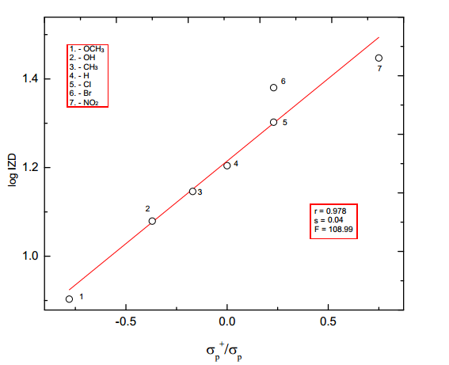

**Figure 2**. Hammett plot for Klebsiella oxytoca

DSP analysis has been performed for each of the resonance scale (σR, σR+, σR-). The best fit of DSP analysis for *Pseudomonas aeruginosa* is taken from satisfactory correlation coefficient (R) and least standard error (SE) of the regression equations (2) and (3) and the result obtained given in **Table 3.**

log (IZD) = (0.33 ± 0.08) σI  + (0.37±0.08) σR + (1.22 ± 0.04) (2)

R = 0.963, SE = 0.05, n = 6, F = 19.09

log (IZD) = (0.35 ± 0.10) F + (0.34 ± 0.08) R + (1.21 ± 0.05) (3)

R = 0.941, SE = 0.06, F = 15.54

The sign of ρI and ρR are positive, reveals that the normal substituent effects operates on IZD, i.e. electron releasing substituents decrease the IZD and electron withdrawing substituents increase the IZD. The ρR values are rather smaller than ρI values and this reveals the importance of polar component.

**Table 3**: DSP analysis of log IZD (mm) with dual parameter equations 2 and 3.

|  |  |  |  |  |  |  |  |  |  |  |
| --- | --- | --- | --- | --- | --- | --- | --- | --- | --- | --- |
| S.No | Bacteria | Scale | ρI | ρR | R | SE | F | Log(IZD)o | n | λ=ρR/ρI |
|
| 1 | Escherichia coli | σI ,σR | 0.24±0.08 | 0.35±0.08 | 0.954 | 0.05 | 15.2 | 1.14±0.03 | 6 | 1.46 |
|  | σI ,σR+ | 0.11±0.20 | 0.15±0.2 | 0.761 | 0.1 | 2.75 | 1.16±0.09 | 7 | 1.36 |
|  | σI ,σRo | 0.28±0.18 | 0.15±0.17 | 0.722 | 0.1 | 1.64 | 1.10±0.07 | 6 | 0.54 |
|  | σI ,σR- | 0.23±0.16 | 0.18±0.14 | 0.790 | 0.1 | 2.50 | 1.11±0.07 | 6 | 0.78 |
|  | F,R | 0.24±0.09 | 0.34±0.07 | 0.945 | 0.05 | 16.8 | 1.14±0.04 | 7 | 1.42 |
|  |  |  |  |  |  |  |  |  |  |
| 2 | Klebsiella oxytoca | σI ,σR | 0.36±0.15 | 0.55±0.16 | 0.931 | 0.09 | 9.81 | 1.21±0.07 | 6 | 1.53 |
|  | σI ,σR+ | 0.17±0.29 | 0.21±0.14 | 0.757 | 0.15 | 2.69 | 1.25±0.14 | 7 | 1.24 |
|  | σI ,σRo | 0.42±0.30 | 0.2±0.29 | 0.663 | 0.18 | 1.18 | 1.14±0.13 | 6 | 0.48 |
|  | σI ,σR- | 0.34±0.28 | 0.28±0.23 | 0.747 | 0.17 | 1.89 | 1.16±0.11 | 6 | 0.82 |
|  | F,R | 0.37±0.19 | 0.45±0.15 | 0.885 | 0.1 | 7.23 | 1.20±0.08 | 7 | 1.22 |
|  |  |  |  |  |  |  |  |  |  |
| 3 | Proteus mirabilis | σI ,σR | 0.45±0.13 | 0.44±0.14 | 0.940 | 0.08 | 11.40 | 1.06±0.06 | 6 | 0.98 |
|  | σI ,σR+ | 0.31±0.26 | 0.17±0.12 | 0.801 | 0.13 | 03.60 | 1.08±0.13 | 7 | 0.55 |
|  | σI ,σRo | 0.51±0.25 | 0.14±0.24 | 0.763 | 0.16 | 02.09 | 0.996±0.1 | 6 | 0.28 |
|  | σI ,σR- | 0.44±0.24 | 0.21±0.19 | 0.814 | 0.14 | 02.94 | 1.01±0.09 | 6 | 0.48 |
|  | F,R | 0.47±0.16 | 0.40±0.12 | 0.918 | 0.09 | 10.67 | 1.04±0.07 | 7 | 0.85 |
|  |  |  |  |  |  |  |  |  |  |
| 4 | Pseudomonas aeruginosa | σI ,σR | 0.33±0.08 | 0.37±0.08 | 0.963 | 0.05 | 19.09 | 1.22±0.04 | 6 | 1.12 |
|  | σI ,σR+ | 0.22±0.21 | 0.13±0.10 | 0.777 | 0.11 | 03.06 | 1.23±0.10 | 7 | 0.59 |
|  | σI ,σRo | 0.37±0.19 | 0.15±0.19 | 0.767 | 0.12 | 02.15 | 1.17±0.08 | 6 | 0.41 |
|  | σI ,σR- | 0.31±0.17 | 0.21±0.14 | 0.839 | 0.1 | 03.58 | 1.18±0.07 | 6 | 0.68 |
|  | F,R | 0.35±0.10 | 0.34±0.08 | 0.941 | 0.06 | 15.54 | 1.21±0.05 | 7 | 0.97 |
|  |  |  |  |  |  |  |  |  |  |
| 5 | Shigella sonnei | σI ,σR | 0.33±0.01 | 0.39±0.1 | 0.950 | 0.06 | 13.88 | 1.09±0.04 | 6 | 1.18 |
|  | σI ,σR+ | 0.21±0.22 | 0.15±0.1 | 0.782 | 0.11 | 03.15 | 1.11±0.10 | 7 | 0.71 |
|  | σI ,σRo | 0.38±0.22 | 0.14±0.2 | 0.731 | 0.13 | 01.72 | 1.04±0.09 | 6 | 0.37 |
|  | σI ,σR- | 0.31±0.18 | 0.22±0.15 | 0.825 | 0.11 | 03.20 | 1.06±0.08 | 6 | 0.71 |
|  | F,R | 0.35±0.13 | 0.33±0.1 | 0.920 | 0.07 | 10.98 | 1.08±0.06 | 7 | 0.94 |
|  |  |  |  |  |  |  |  |  |  |  |
| 6 | Staphylococcus aureus | σI ,σR | 0.38±0.15 | 0.61±0.16 | 0.940 | 0.09 | 11.34 | 1.18±0.07 | 6 | 1.61 |
|  | σI ,σR+ | 0.19±0.32 | 0.22±0.15 | 0.745 | 0.16 | 2.49 | 1.20±0.15 | 7 | 1.16 |
|  | σI ,σRo | 0..45±0.33 | 0.23±0.32 | 0.650 | 0.2 | 1.14 | 1.09±0.14 | 6 | 0.51 |
|  | σI ,σR- | 0.35±0.24 | 0.35±0.28 | 0.780 | 0.17 | 2.32 | 1.13±0.12 | 6 | 1.00 |
|  | F,R | 0.42±0.22 | 0.44±0.17 | 0.860 | 0.12 | 5.63 | 1.15±0.09 | 7 | 1.05 |

The Yukawa-Tsuno equation 4 and **Table 4** for Escherichia coli proved the less contribution of resonance effect.

log IZD = (0.171±0.05) σpo + (0.211 ± 0.05) (σp+ - σpo) + (1.18 ± 0.02) (4)

(R = 0.981,SE = 0.03, n = 6, F = 38.16)

**Table 4:** Results of multiple regression analysis of log IZR (mm) with σp,( σp+- σp)  and σpo,

(σp+- σpo) constants using Yukava – Tsuno equation (4).

|  |  |  |  |  |  |  |  |  |
| --- | --- | --- | --- | --- | --- | --- | --- | --- |
| S.No. | Bacteria | scale | ρ | r | R | SE | F | n |
| 1 | *Escherichia coli* | σp,( σp+- σp) | 0.205±0.06 | 0.279±0.11 | 0.975 | 0.04 | 28.35 | 6 |
|  |  | σpo,( σp+- σpo) | 0.171±0.05 | 0.211±0.05 | 0.981 | 0.03 | 38.16 | 6 |
| 2 | *Klebsiella oxytoca* | σp,( σp+- σp) | 0.287±0.12 | 0.494±0.23 | 0.956 | 0.07 | 16.09 | 6 |
|  |  | σpo,( σp+- σpo) | 0.236±0.11 | 0.353±0.12 | 0.957 | 0.07 | 16.21 | 6 |
| 3 | *Proteus mirabilis* | σp,( σp+- σp) | 0.386±0.14 | 0.237±0.27 | 0.938 | 0.08 | 11.02 | 6 |
|  |  | σpo,( σp+- σpo) | 0.316±0.13 | 0.243±0.13 | 0.841 | 0.08 | 11.55 | 6 |
| 4 | *Pseudomonas aeruginosa* | σp,( σp+- σp) | 0.294±0.08 | 0.133±0.15 | 0.959 | 0.05 | 16.95 | 6 |
|  |  | σpo,( σp+- σpo) | 0.242±0.09 | 0.15±0.09 | 0.945 | 0.06 | 12.42 | 6 |
| 5 | *Shigella sonnei* | σp,( σp+- σp) | 0.294±0.1 | 0.239±0.19 | 0.954 | 0.06 | 15.04 | 6 |
|  |  | σpo,( σp+- σpo) | 0.239±0.09 | 0.215±0.1 | 0.948 | 0.06 | 12.24 | 6 |
| 6 | *Staphylococcus albus* | σp,( σp+- σp) | 0.326±0.14 | 0.504±0.26 | 0.953 | 0.08 | 15.01 | 6 |
|  |  | σpo,( σp+- σpo) | 0.272±0.14 | 0.637±0.26 | 0.942 | 0.09 | 11.74 | 6 |
|  |  |  |  |  |  |  |  |  |

**CONCLUSION**

To summarize, substituted 5-benzylidenebarbituric acidshave been synthesized and evaluated for their antibacterial activities. This reaction protocol offers a simple, easier work-up procedure and good yields. The compounds have been characterized by their spectral data. The antimicrobial activities of all synthesized compounds have been studied. The inhibition zone diameter of these compounds has been correlated with Hammett substituent constants, F and R parameters. From the results of statistical analysis, the effects of substituent on the antimicrobial activity of compounds have been studied.

**REFERENCES**

1. The Merck Index, Budavari S., editor, 11th ed., Merck, Rahway, N.J. USA, (1989).
2. Yoneda, F ; Hirayama, R and Yamaashita, M., *J.Heterocycylic Chem.,* **19**, **(**1982),301.
3. Blythin, D.J.; Donalski, M. S.; Kuo, J. and Liu, J.H., *Heterocycles* , **16**, (1981) 203.
4. Cheng, X.; Tanaka, K. and Yoneda, F., *Chem.Pharm.Bull.,***38**, (1990) 307.
5. Yoneda, F.; Hirayama, R. and Yamashita, M., *Chem.Lett*., (1980) 1157.
6. Tanaka, K.; Cheng, X.; Kimura, T. and Yoneda, F., Chem.Pharm.Bull., **34**, (1986) 3945.
7. Figueroa-Villar, J.D.; Rangel, C.E. and Dos Santos, L.N.; *Synth, Commun.,***22(8)**, (1992)

1159.

1. Tanaka, K.; Cheng, X. and Yoneda, F., *Tetrahedran*, **44**, (1989)1803.
2. Ikeda, A.; Kawabe, Y.; Sakai, T. and Kawasaki, K., *Chem.Lett*., (1989) 1803.
3. Guadalupe Alcerreca, Ruben Sanabria, Rene Miranda, Gabriel Arroyo, Joaquin Tamariz

and Francisco Delgado, *Synth.Commun.,***30(7)** (2000) 1295.

1. Raman, N. and Ravichandran, S., *Asian J. Chem.,* **14** (2002) 1766.
2. Raman, N. and Ravichandran, S., *Asian J. Chem.,* **15** (2003) 1848.
3. Radhakrishnan, K.; Mohandass P.;Sankaralingam, S. and Chandramohan, S., Der Chemica

Sinica., 7(4) (2016) 1.

1. Branko S. Jursic., *J.Heterocyclic Chem.,* **38**, (2001) 655.